

FUNDAMENTALS OF PROGRAMMING

ASSIGNMENT 2

**NAME: Daniyal Ahmed**

**CMS:457165**

**CLASS:ME-15 (SECTION-B)**

**DATE : 11-10-2023**

**TASK 1**

#include <iostream> //*the included library is input output stream*

using namespace std; //*name of space* *is declared as std*

int main(){

int S; //*S is declared as an integer*

cout<<"Enter your score "; //*A string is shown to enter score*

cin>>S; //input your score

if(S>=90 && S<=100) //*it says that if score is b/w 90 and 100*

{

cout<<"Your grade is A "; //*it will output grade A if condition is satisfied*

}

else if(S<90 && S>=75) //*it says that if score is b/w 75 and 90*

{

cout<<"Your grade is B "; //*it will output grade B as per condition*

}

else if(S<75 && S>=60) //*it says that if score lie b/w 60 and 75*

{

cout<<"Your grade is C "; //*as per condition it will output grade C*

}

else if (S<60 && S>=45) // *it says that if score lie b/w 45 and 60*

{

cout<<"Your grade is D "; //*if condition above is fulfilled , then it will show D grade*

}

else if(S<45 && S>=0) // *it says that if score lie b/w 45 to zero*

{

cout<<"Your grade is F "; //*as a result F grade will be shown*

}

else

{

cout << "Please write number from 0 to 100";

}

return 0;

}

}

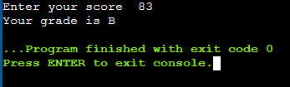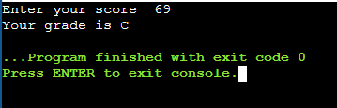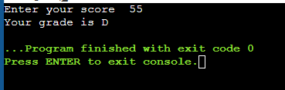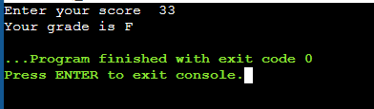

**TASK 2**

#include <iostream> //*the included library is input output stream*

using namespace std; //*name of space* *is declared as std*

int main()

{

int num; //*num is declared as an integer*

cout<<"Enter the number "; //*string is shown to input number*

cin>>num; //*input value of num*

if (num%2==0 && num%5==0) //*here we put the modules so that num is divisible by 2 and 5*

{

cout<<"Number is even and divisible by 5."; //*if this condition is fulfilled then num is a multiple of 10*

}

else if(num%2==0) //*if num is a multiple of 2*

{

cout<<"Number is even but not divisible by 2.";

}

else if(num%5==0) //*if num is only a multiple of 5 but not 2*

{

cout<<"Number is odd but is divisible by 5,";

}

else //*if both those conditions are not fulfilled then it is done*

{

cout<<"Number is neither even nor divisible by 5.";

}

return 0;

}

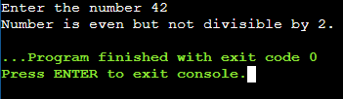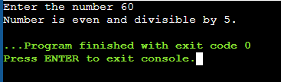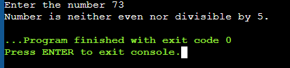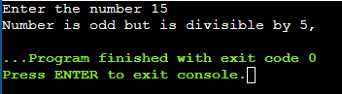

**TASK 3**

#include <iostream> //*the included library is input output stream*

using namespace std; //*name of space* *is declared as std*

int main ()

{

int year; //*year is declared as an integer*

cout<<"Enter the year : "; //*string is shown to enter year*

cin>>year; //*value of year should be entered*

if(year%4==0 && year%400!=0) //*if 4 is a factor of year but 400 is not then it is leap year*

{

cout<<"The year is a leap year.";

}

Else //*or else it is not leap year*

{

cout<<"The year is not a leap year.";

}

return 0;

}

.

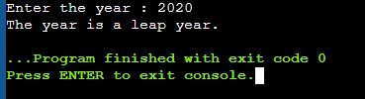

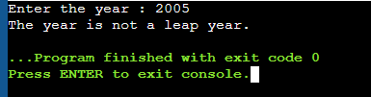

**TASK 4**

#include <iostream> //*the included library is input output stream*

using namespace std; //*name of space* *is declared as std*

int main()

{

double GPA,attendance; //*GPA and attendance are declared as a double because they can be in decimals*

cout<<"Enter your GPA : "; //*string is shown to enter GPA*

cin>>GPA; //*enter GPA value*

cout<<"Enter your attendance : "; //*string is shown to enter attendance*

cin>>attendance; //*enter attendance value*

if (GPA>=3.5 && attendance>=80) //*if GPA is not less than 3.5 and attendance is not less than 80%*

{

cout<<"The student is eligible for scholarship."; //*eligibility of student is shown*

}

else if(GPA<3.5) //*if GPA is less than 3.5*

{

cout<<"The student has less than 3.5 GPA so is not eligible for scholarship.";

}

else if(attendance<80) //*attendance is less than 80%*

{

cout<<"The student has less than 80% attendance so is not eligible for scholarship. ";

}

return 0;

}

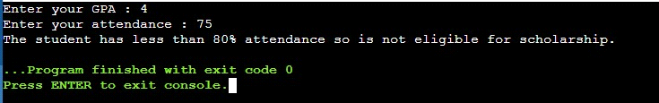

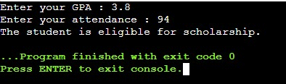

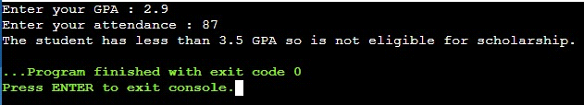

**TASK 5**

#include <iostream> //*the included library is input output stream*

using namespace std; //*name of space* *is declared as std*

int main()

{

char letter; //*letter id declared as a character*

cout<<"Enter the letter : "; //*string is shown to enter letter*

cin>>letter; //*input your letter*

if(letter=='a' || letter=='e'|| letter=='i' || letter=='o' || letter=='u') //*if the letters are a,e,i,o,u*

{

cout<<"The letter is a vowel"; //*if condition is satisfied then it tells that letter is vowel*

}

else

{

cout<<"The letter is a consonant. "; //*otherwise it is not vowell*

}

return 0;

}

